**1050 Programming Logic**

Lab 6 (14 points total)

Name: ___________________________

***Paste your code and screenshots of the console as below.***

1. Use a while loop and if statement to write a program that prints the next 20 leap years (2 points).
2. using System;
3. using System.Collections.Generic;
4. using System.Linq;
5. using System.Text;
6. using System.Threading.Tasks;
7. namespace Lab_6._1
8. {
9. class Program
10. {
11. static void Main(string[] args)
12. {
13. for (int year = 2016; year <= 2100; year+=4)
14. {
15. Console.WriteLine(year + 4);
16. }
17. Console.ReadLine();
18. }
19. }
20. }
21. Write a guessing game where the user has to guess a secret number. After every guess the program tells the user whether their number was too large or too small. At the end the number of tries needed should be printed. To keep it simple, input the number at the beginning of the game. (6 points).

using System;

using System.Collections.Generic;

using System.Linq;

using System.Text;

using System.Threading.Tasks;

namespace Lab_6._2._1

{

class Program

{

static void Main(string[] args)

{

int answer = 0;

int guess = 0;

Random number = new Random();

answer = number.Next(1, 20);

for (int i=1; i<=5; i++)

{

if (i == 5)

{

Console.Write("Enter Guess {0}:", i);

}

guess = Convert.ToInt32(Console.ReadLine());

if (guess==answer)

{

Console.WriteLine("You lose. The answer is {0}", answer);

}

else

{

if (guess==answer)

{

Console.WriteLine("Guess is higher");

}

else if (guess > answer)

{

Console.WriteLine("Guess is lower");

}

}

}

Console.ReadKey();

}

}

}

1. Create a while loop. The while loop will continue to run until the user inputs a value of “E”. During the loop, accept two other inputs: grocery item and cost. Keep a running total of the cost. Also, add the item to a string. When the loop is complete, display the items and the total cost. (6 points)

Example:

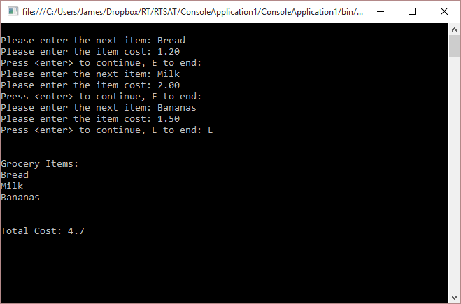

Example Code for keeping track of grocery items:

Console.Write("Please enter the next item: "); // this would go before the while loop

item = Console.ReadLine(); // this would go in the while loop

allItems += item + "\n";

3) using System;

using System.Collections.Generic;

using System.Linq;

using System.Text;

using System.Threading.Tasks;

namespace Lab_6._3

{

class Program

{

static void Main(string[] args)

{

String item = "";

double cost = 0.0;

double total = 0.0;

string list = "";

while (item != "E")

{

Console.Write("Please enter the next item: ");

item = Console.ReadLine();

Console.Write("Please enter the cost: ");

cost = Convert.ToDouble(Console.ReadLine());

total = total + cost;

list += item + "\n";

}

Console.WriteLine(list);

Console.WriteLine(total);

}

}

}

**Deliverables:**

When Complete, please push to GitHub and submit the URL to your repository in Blackboard.